# Practical No: 04

**Aim:** Planning Network-based Firewalls

**Components:** Wireless Router, Server, PC

**Theory:** Network firewalls are security devices used to stop or mitigate unauthorized access to private networks connected to the Internet, especially intranets. The only traffic allowed on the network is defined via firewall policies – any other traffic attempting to access the network is blocked.

**Cisco Packet Tracer Setup:- Implementation:**

**Step 1:** Arranging devices and creating connections

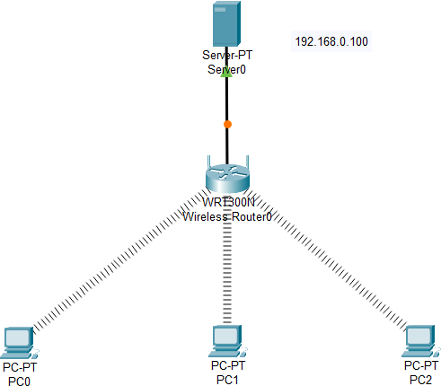

**Step 2:** Configure wireless router and connect server to wireless router using Ethernet cable

**Step 3:** Configure Server by setting IP Config in Server0 to DHCP

**Step 4:** Configure and connect all PC’s to wireless router

**Step 5:** Changing port to wireless adapter of all PC’s

After adding wireless adapter of all PC’s they will automatically get connected with wireless router because of DHCP

**Step 6:** Checking connection of pc’s with server

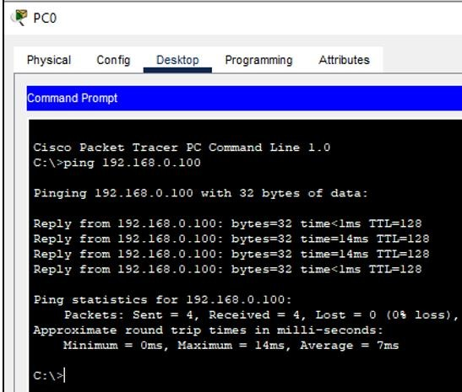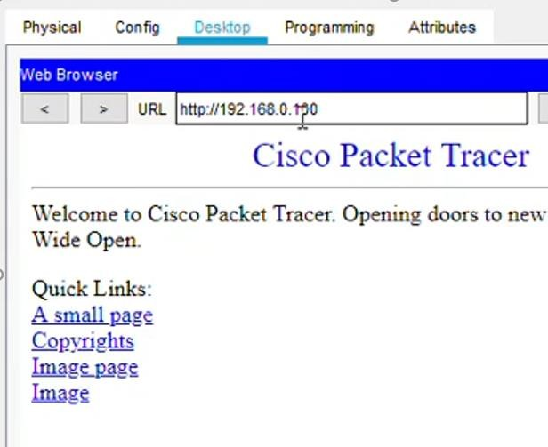

If receiving response from server our connection is done successfully

**Step 7:** Configure IPv4 firewall to setup networks based firewall and add conditions

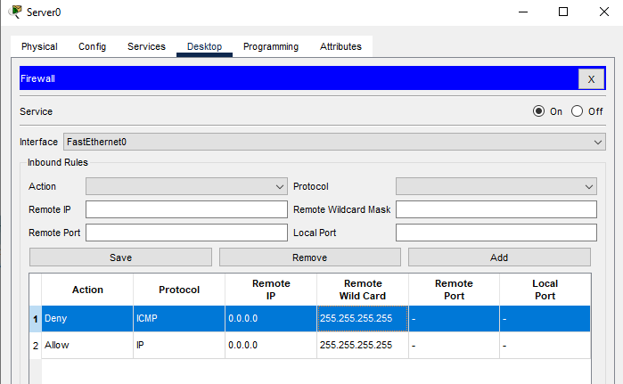

**Output:**

After the configuration is done for firewall we are unable to ping to server

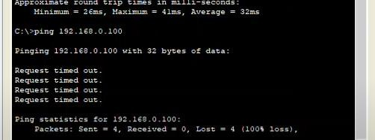

But we can access the server data (view)

